Build a Docker Image Using a Custom Dockerfile

- Build a Docker image from the Dockerfile.
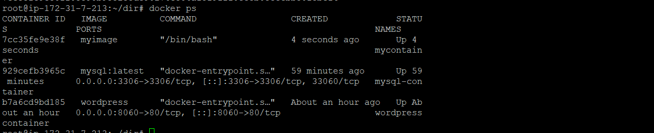

Vim:
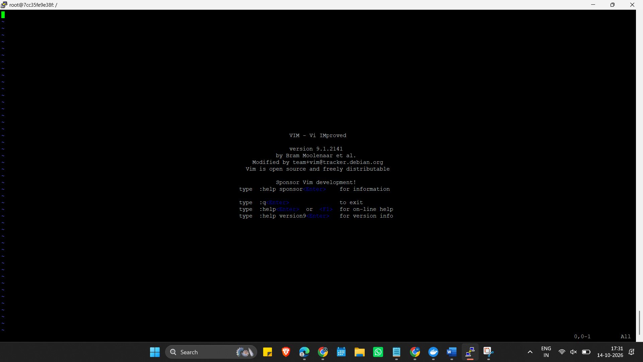

Wget:
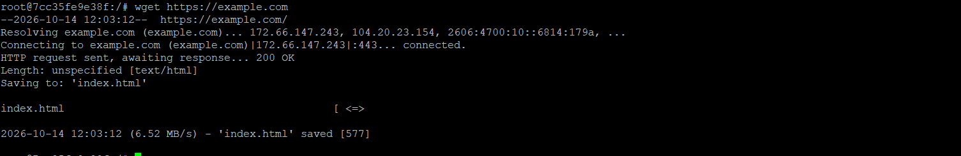

Unzip:
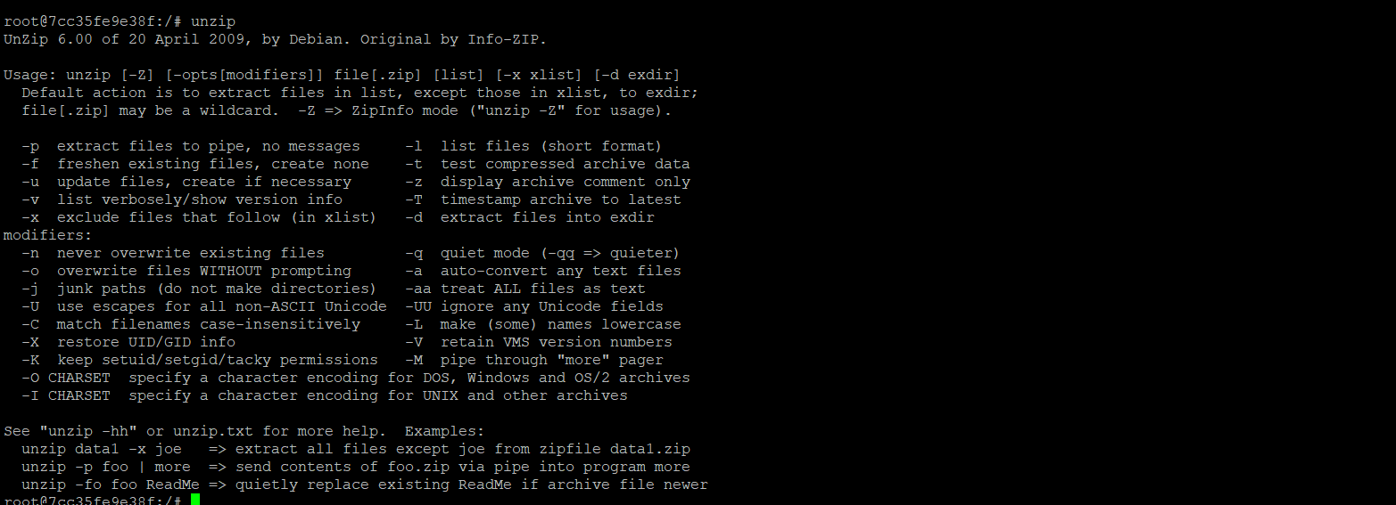

Now remove unzip and install php instead

